How To Create Account
1: Log into the following website
https://www.ahcancal.org/Pages/Default.aspx
2: Click on the sign in button at the top left of the screen
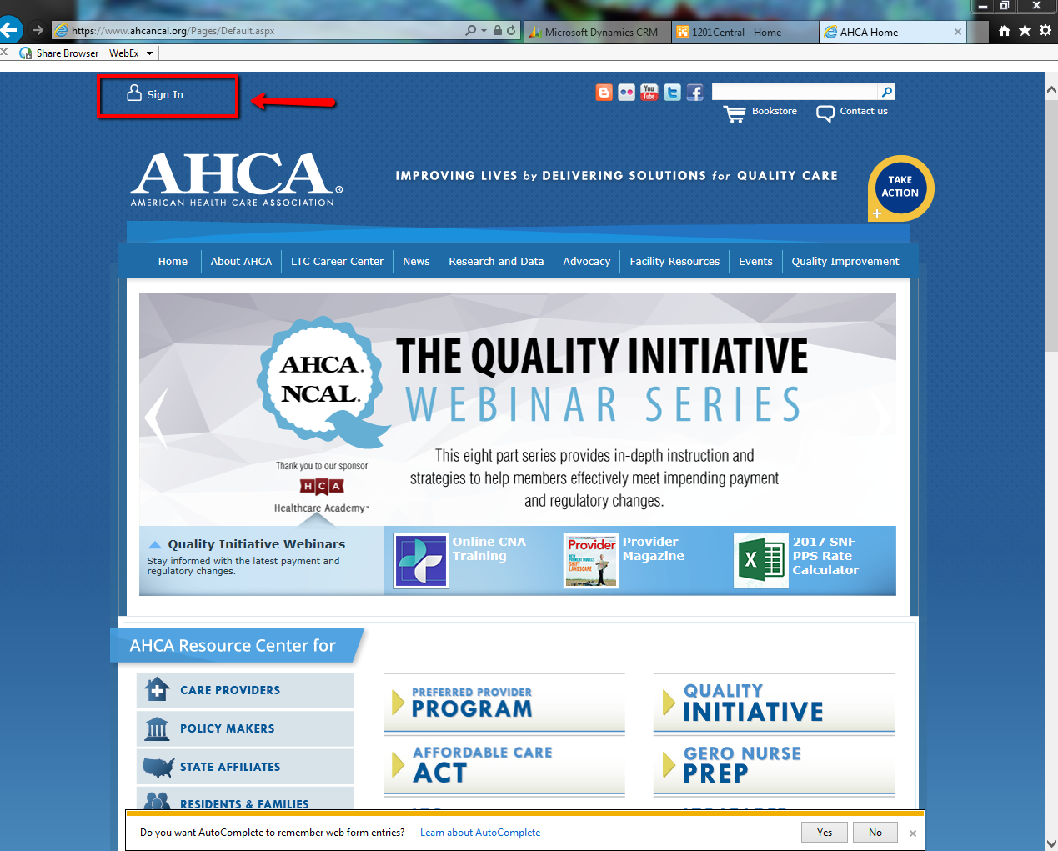
3: Click on “Not sure what your username or password is, or if you have an account? Go here. “and click on Go here.
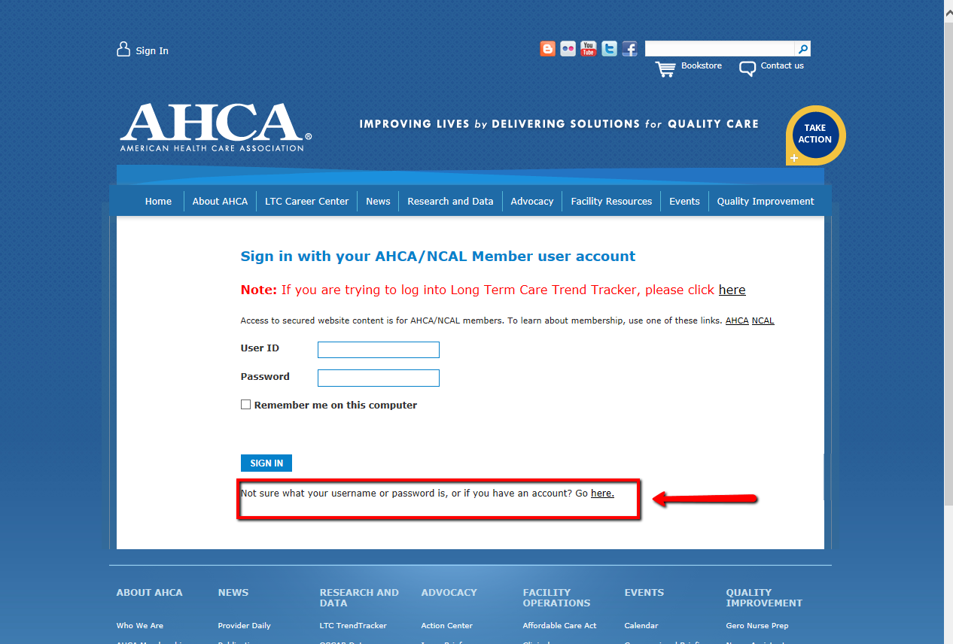

4: click the first bubble “I am not sure I have an account or what email I used for my user account”
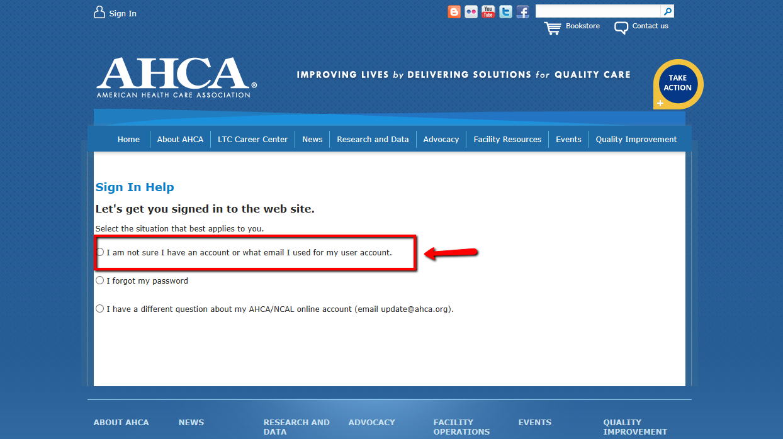
5: it will direct you to this page where you will put in your company email address. After you type in your email address you click find my user account.
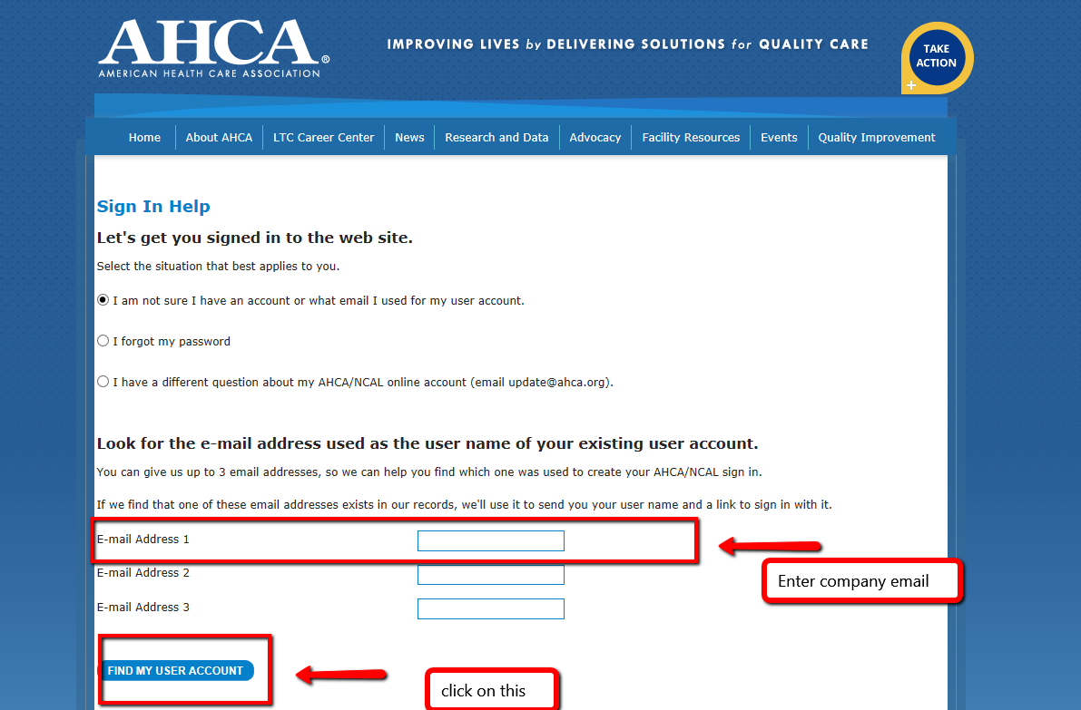
6: This screen will pop up and you will click the create new user account bubble, then click next.
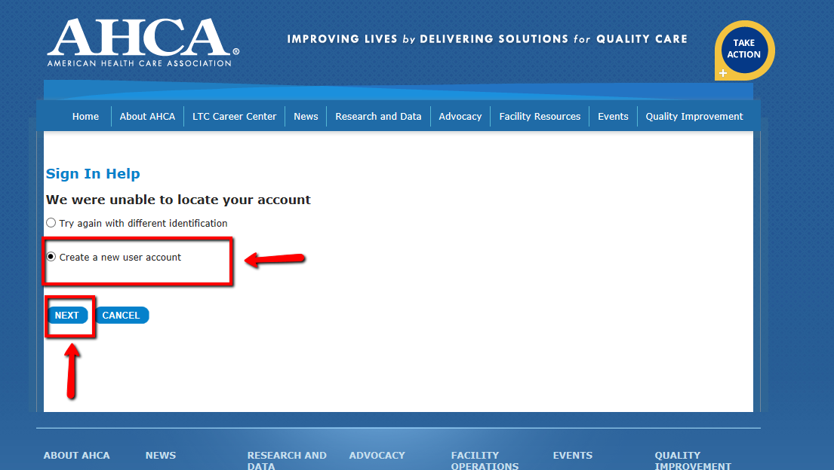
7: fill out all the information on the screen and please make sure to click on “Identify my Company” to add the company you are working with.
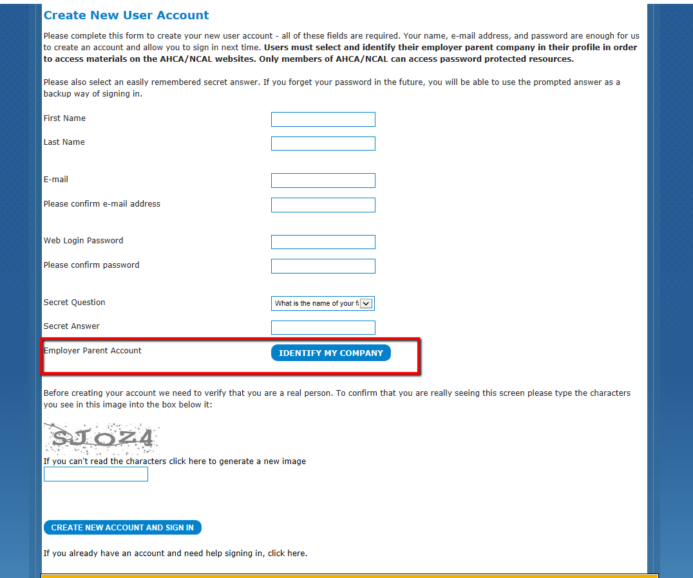
8: the identify my company screen will look like this. You will type your company where is says account name and hit search. Once you find your company you will click on it and hit save. Below is just an example please make sure to enter your facility name. 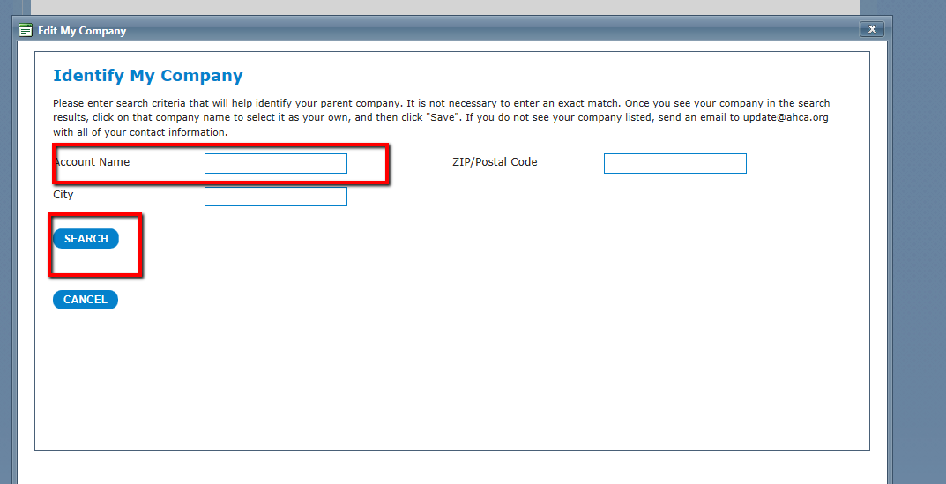
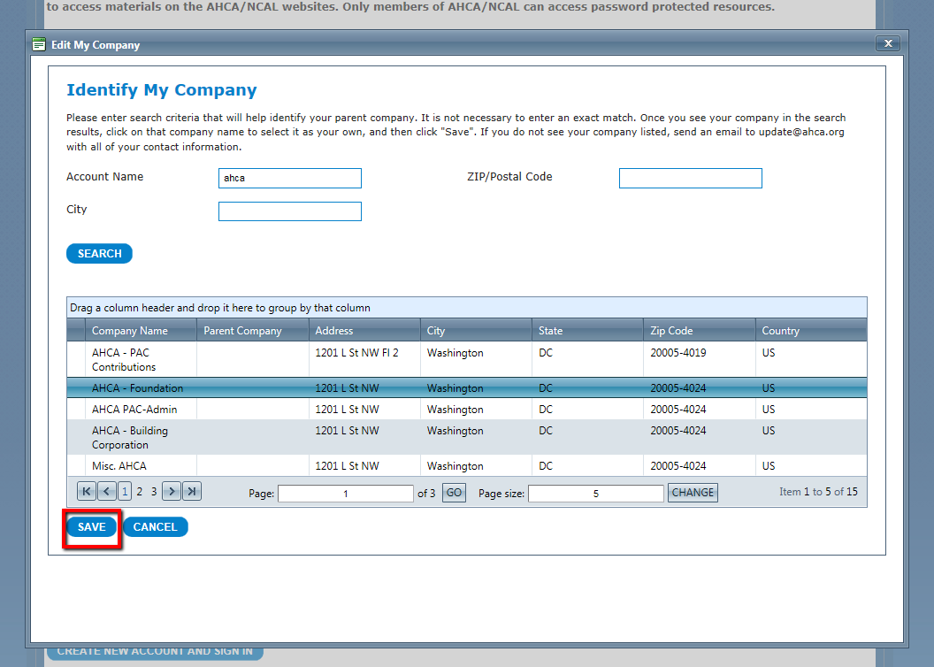

9: last step is to click on create a new account and sign in.

